**Data Story – Performing Data Visualization on Loan Data**

Data Snapshot:

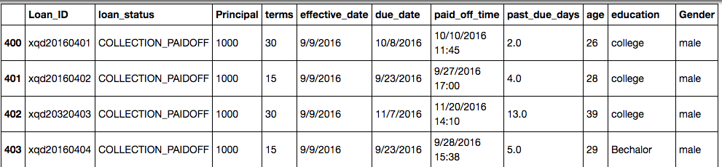

Some questions and finding:

1. How do male and female compare when it comes to Paid Off, Collection and Collection Paid Off loans AND what is the concentration of males and females in the dataset.

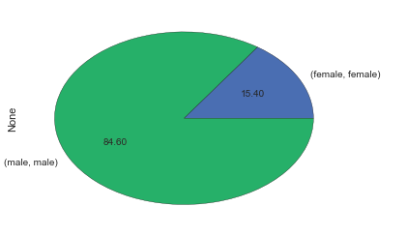

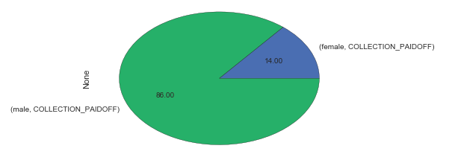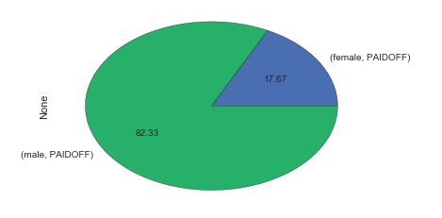

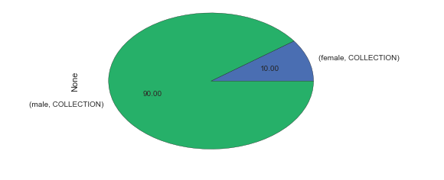

Findings: Males are predominant loan customers as Males and Females form an approx 85 and 15 % of population respectively.

For Paid Off and Collection Paid Off loan statuses, males and female fare consistently as per there concentration.

For Collection statuses, males are in slightly higher concentration as defaulters (9:1)

1. How are loan amounts (without standard deviation 3 outliers) varying per education qualifications of the applicants?

High School or Below:

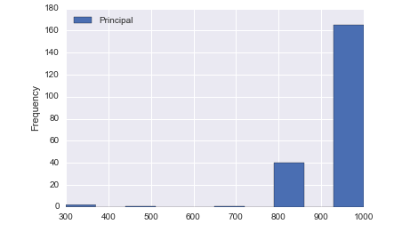

Bachelors:

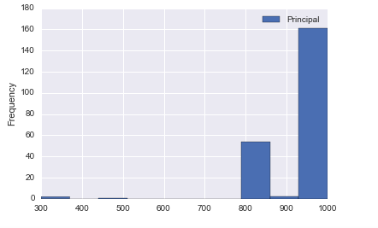

College:

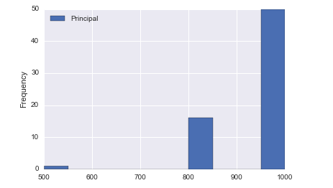

Master or Above:

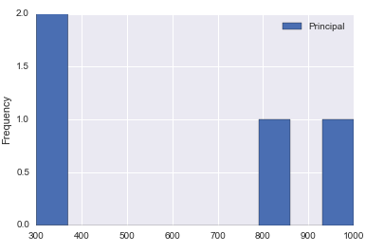

Findings: There is a comparatively higher no. of Masters educated applicants for smaller loan amounts, others have higher concentration for bigger loan amounts

1. Correlation between age and principal amount using scatter plot?

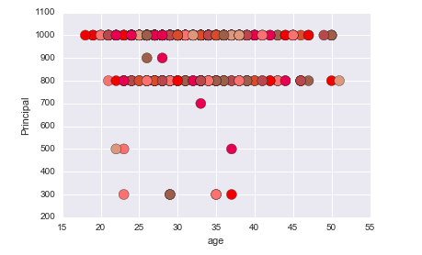

It is observed the majority of the loan amounts (Prinicpal) are in range of 800-1000, and applicants who’ve applied for smaller loan amounts are no older than 40.

1. How is due date and principal related? (time-series plot)

